**Why Edgenuity is not where kids should be learning**

Created by: NSAA Edgenuity Is Bad Bureau   
Written by: Zane Miller

Edited by: Harrison steed

The week after Spring break, all Cy - Fair schools closed down due to the crisis. One week later, the administration assigned online learning to all students in Cy - fair. The main classes were assigned through Edgenuity - A web based learning platform which is riddled with problems. In this article, I will explain why Edgenuity is awful, and why kids shouldn’t be using it for learning at home.

**Problems with Videos and Activities**

1. Long tasks and unskippable videos

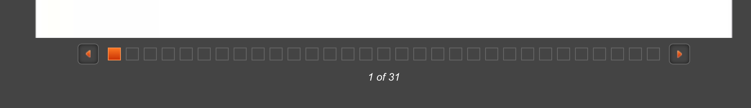

The videos on Edgenuity are the worst part of the service. They are not engaging whatsoever, and the teachers sound like robots. But by far, the worst part about the videos is that you can’t skip them. Factor in the fact that the only K level class offered is math, you have a problem. If you watch a video about something you already know, you can’t skip the video. That’s right. You can’t skip the boring videos, even if you know the material. The tasks are not great either - they are long and don’t teach the material well. Shown above is an activity that is 31 tasks long. An activity that long would probably take over an hour to complete, CFISD recommends you take 45 minutes for each subject, every day - see the problem?

1. Activities in the lesson that are longer than what the lesson should be

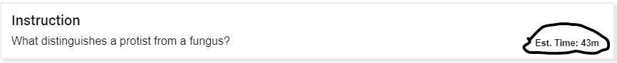

This entire activity is 43 minutes long - and the shocking part is, it is not the same activity with 31 tasks. With this instruction taking 43 minutes, you would have to go to the next subject when you are finished. This means you would have to do 2 entire lessons the next day, or you won’t meet the Edgenuity recommendation of one lesson per subject, per day.

**Glitches and Bugs**

**These are unintentional, annoying issues that lead to bigger problems**

1. Error 404 messages

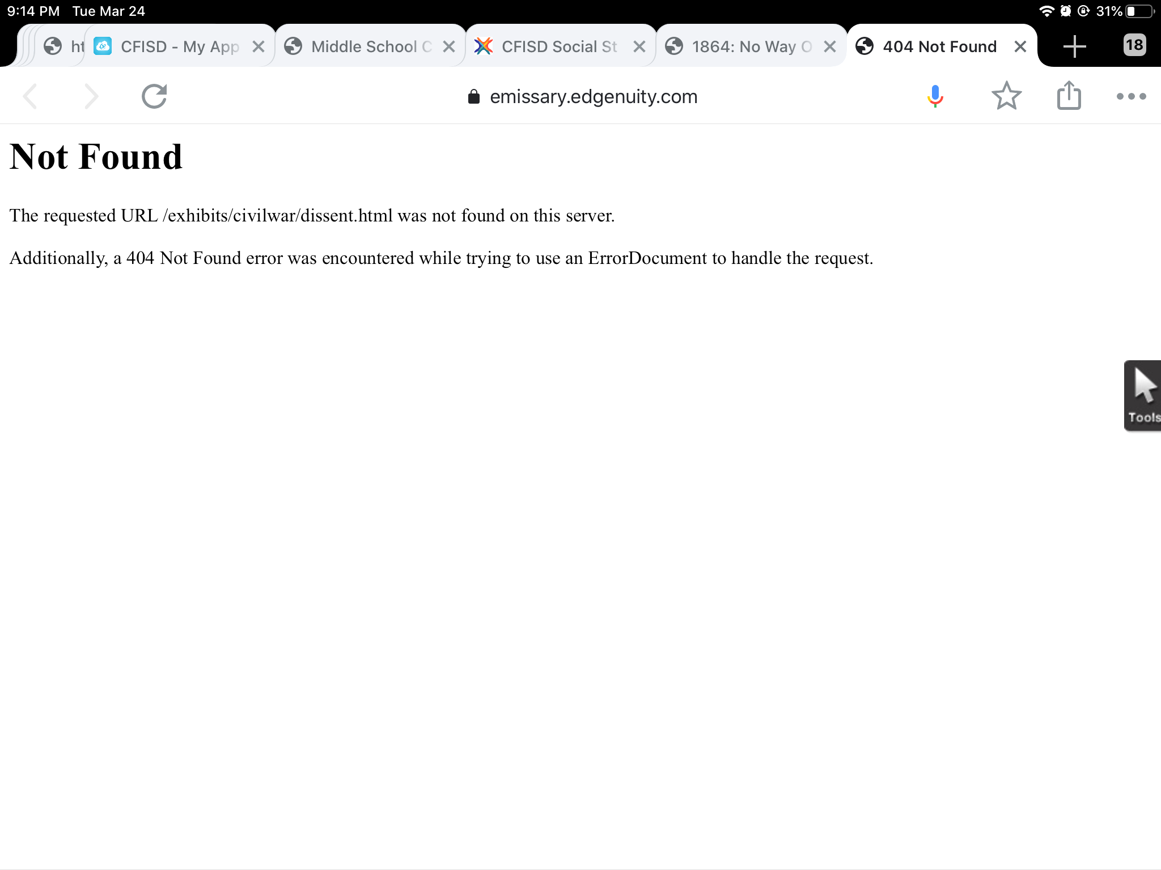

The Edgenuity system itself is, (to quote my friend, Collin Pepper) - “Just soul crushingly bad “. There are many instances where I am using Edgenuity, they tell me to click on a link and read an article, and the article isn’t even there. I get an error 404 message.

1. Unexpected errors

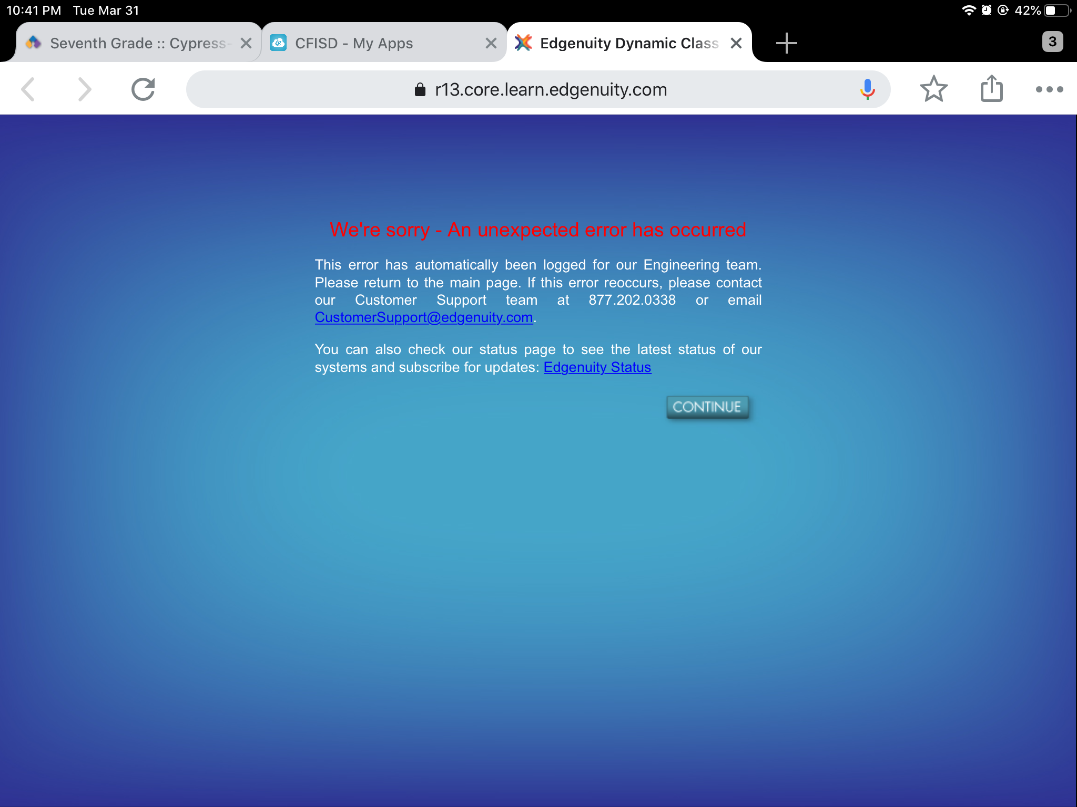

The picture above shows an “unexpected error”. This has happened to me many times, and guess what? I failed three assignments because of this. The edgenuity system is incredibly outdated - I heard one of the instructors say Obama was the president, this means it was made around 2008 - 2016. Some of the articles aren’t even around anymore. I feel it is unfair for the district to make us use Edgenuity for learning, because if you can’t get the content, how can you learn?

The system also has a few other minor flaws that I would like to point out.

1. This video gives a false time.



1. This test has a typo.

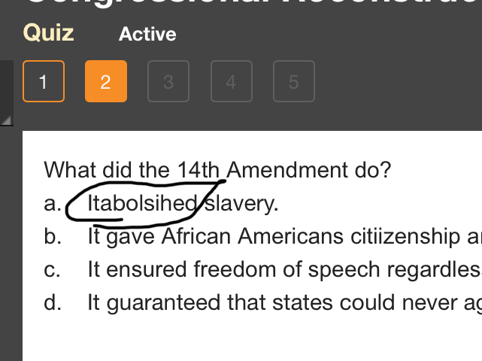

1. It says to write two paragraphs in two boxes, but there is only one box

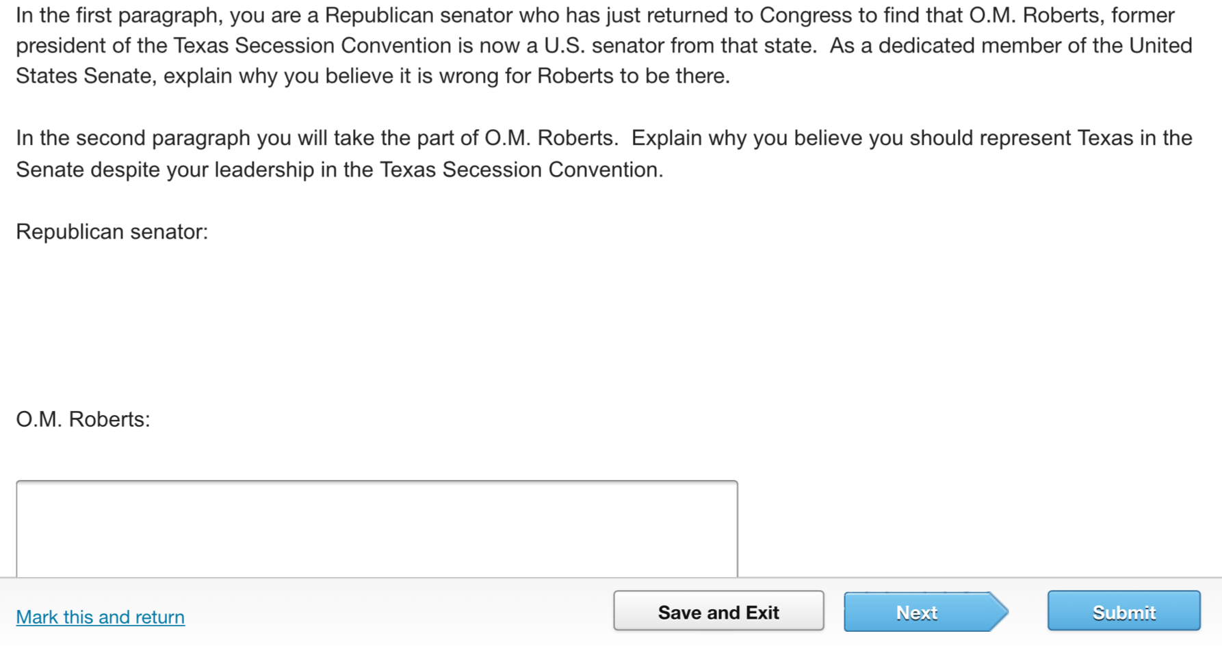

Earlier I said - “If you can’t even get the content how can you learn?” Well this...this...is just evil. In this assignment you are supposed to write two paragraphs. It gives you two spaces to write paragraphs but you only get one text box. If the question doesn’t even let you do what you need to do, how can kids pass?

1. Case sensitivity

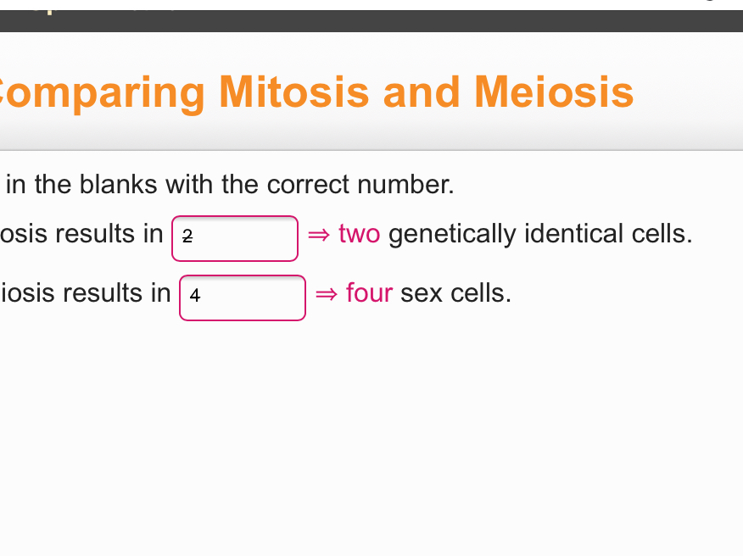

Why? I got this question wrong because I typed 2 and 4 instead of Two and Four.

**Major Flaws**

1. Not being able to have duplicate tabs open.

This issue can be understandable - Edgenuity doesn't want someone to cheat on a Quiz by looking at the lesson (The answers) from another tab. But if you are on two different subjects, the system should allow it. If you are playing a long, unskippable video for one subject, you should be able to do work for another subject in a different tab.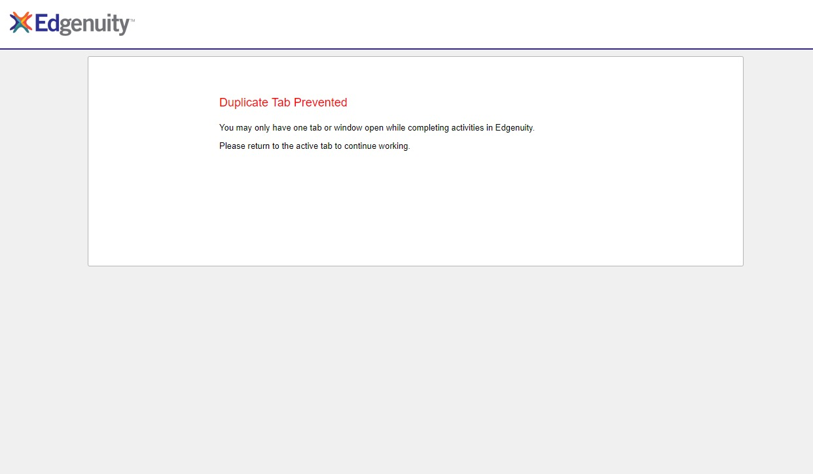

1. Session Time-out after 30 minutes of inactivity.

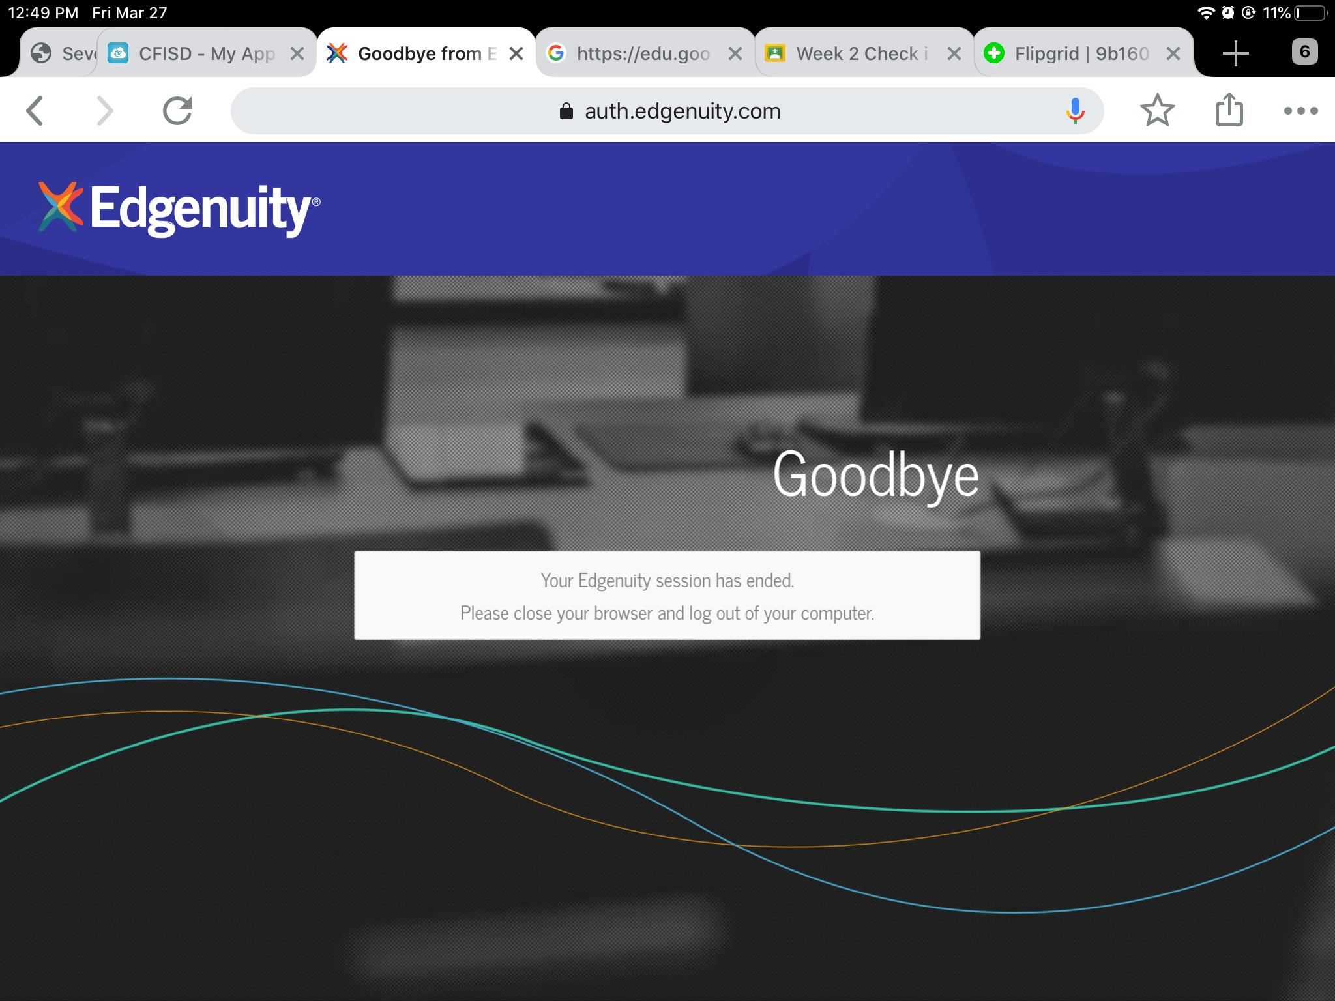

After about 30 minutes of inactivity, the system will log you out - If you are not active, you get logged off. I think this is outrageous. I could finish a lesson, eat lunch for 30 minutes, come back to do more work, and have to log in all over again! Unlike the duplicate tabs issue, the automatic log out has no logical reason, and is just another annoying feature that is worthless, and makes the system harder to use.

**Everyone Agrees**

And it is not like I am the only one who thinks this. I have personally met with multiple kids who say Edgenuity is horrible. To quote a few:

“Edgenuity is just soul crushingly bad “ - Collin Pepper, enterprise incorporated employee

“Edgenuity is a curse that has been bestowed upon the innocent souls of this district, striking people with boredom and annoyance. This scourge is quite a terrible one but edgenuity is as horrible as the scourge itself “ - Rahat Hasan - Co owner, COO of the NSAA.

“Edgenuity is slow and boring. I know they mean well by trying to teach us at home, but there are other ways that are Faster, Easier, and just plain better “ - Harrison steed - Co founder, Co owner, CEO of the NSAA.

“I guess i don’t like it. The thing is I’m too lazy to do it “ Nick - NSAA employee

“Edgenuity is boring “ Tristan gladin - NSAA employee

“Online learning is very fast paced and it’s hard “ Austyn wynn - Aragon student.

"So I got a question wrong because I didn't put a zero before a decimal place" Steven Stewart - enterprise incorporated employee

“Its big bad “ Bryson Oliver - NSAA employee

"I'm going to be working on this for hours. How is this 45 minutes?" Ryan - Aragon student.

" It's gay " - Thomas - Aragon student

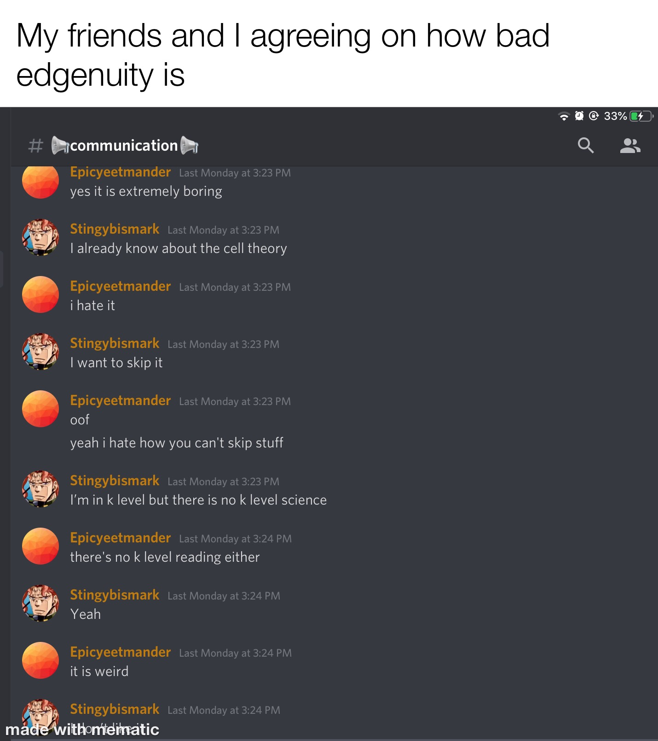

**Conclusion and summary**

All in all, this is my reasoning on why Edgenuity should not be used as the primary online learning system for Cy - Fair ISD.

Reasons:

* The system has many bugs and glitches.
* You don’t get an advanced level language arts, Science or social studies.
* The videos are boring and not engaging.
* You can’t skip the videos.
* They automatically log you off for inactivity.
* It is case sensitive.
* It doesn’t let you have duplicate tabs.
* The online content doesn’t load at times.
* The questions may lead to wrong answers, due to errors in the wording.
* It is outdated
* There are many typos.
* The activity lengths are too long for the Cy - fair recommendations.

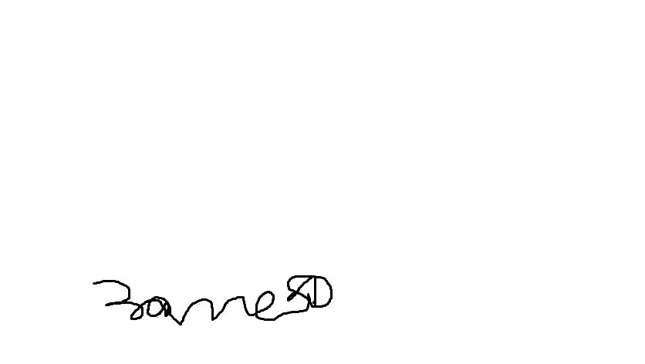

Signed, Zane Miller - Co Founder, Co - Owner, CCO of the NSAA